Multitone radio system

01FE19BEC265

01FE19BEC266

01FE19BEC274

01FE19BEC276

01FE19BEC248

YASH MAHALE

IFRA

BHARAT GUNHALKAR

MUKTA WARAD

NIRANJAN BHUTTI

Contents

1 Introduction 2

Information Source: 2

Transmitter: 2

Channel: 3

Noise: 3

Receiver: 3

Destination: 4

2 Theory and Design of Transceiver 4

3 Simulation Setups 5

4 Simulation Results 6

5 Hardware Setup 7

6 Hardware Results 8

7 Conclusion 9

# Introduction

The process of exchanging information is known as communication. Source, transmitter, channel, receiver, and destination are the basic components of a communication system. An electronic communication system is depicted in the diagram below in its general form.

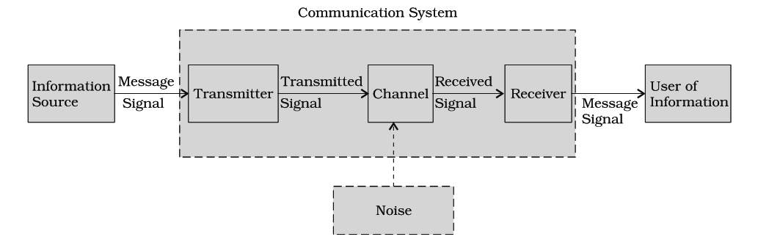

Description of a communication system is given as under:

* The sender (Information Source) who creates the message to be transmitted
* A medium that carries the message
* The receiver (User of Information) who receives the message

## Information Source:

A source is a device that generates data or messages to be sent. It could be something as simple as a microphone or a computer keyboard. The messages produced by the source can be analogue or digital in nature. Below is an example of analogue and digital information sources.

* Analog Information Source: Microphone, Camera, TV signal
* Digital Information Sources: Teletype, output of computer – consists of discrete symbols or letters.

## Transmitter:

The transmitter's first task is to convert the input messages generated by the source (for example, a voice signal) into an electrical form suitable for transmission. A microphone is used to convert sound into an electronic audio signal when sending voice messages. A camera converts light information into video signal for television. A device that converts one form of energy into another is referred to as a transducer. It's worth noting that a speaker is also a transducer, which converts electrical signals back to voice signals. It's also worth noting that the transmitter's primary function is modulation. The message signal is mathematically mixed or superimposed with the high frequency carrier signal during modulation. Other functions of the transmitter include audio frequency range restriction, amplification, and so on. It's worth noting that all of this processing is done solely to facilitate signal transmission from transmitter to receiver. Advantages of modulation are: long distance transmission, high speed of transmission. Modulation also allows the reliable (practically achievable) sizes of antennas at transmitter and receiver.

## Channel:

The transmitter in a communication system is located in one location, while the receiver is located in another. The physical medium that connects them electrically is called a channel. The medium through which a message signal is transmitted is referred to as a channel. A channel can take the form of wires or cables, depending on the type of communication system. Copper wires, coaxial cable, optical fibre, radio links, satellite channel, or a combination of these are the various channels. If you're calling someone in the United States, the call could travel by air, sea, or space, for example. The channel is made up of wires, radio connections, satellites, and undersea cabling in this case. Bandwidth and Signal to Noise Ratio are two important channel parameters (SNR). The signal-to-noise ratio (SNR) is the ratio of signal power to nose power. The ideal signal-to-noise ratio is for the signal power to be very high and the noise power to be zero. BANDWIDTH and POWER are two other important characteristics of the channel. The signal-to-noise ratio (SNR) is the ratio of signal power to nose power. The ideal signal-to-noise ratio is for the signal power to be very high and the noise power to be zero. BANDWIDTH and POWER are two other important characteristics of the channel.

## Noise:

Noise is an unwanted signal that disrupts, interferes with, and affects the signal being transmitted. We can't stop it from happening, but we can make it less likely. Noise is a random signal with unpredictable behaviour. SNR is a noise measurement that is commonly used (Signal to Noise ratio). The signal-to-noise ratio (SNR) is the ratio of two quantities: signal power and noise power. SNR values are expressed in decibels (dB). It's worth noting that for best results, a very high SNR is recommended.

## Receiver:

The receiver's primary function is to reconstruct the transmitted signal and deliver it to the intended recipient, known as the information user. It accepts the channel's transmitted message and converts it to a human-readable format. Amplifiers, oscillators, mixers, tuned circuits, filters, and a demodulator are all found in receivers (detector). Demodulation is the process of removing the carrier from a signal that has been transmitted. Decoding, decompression, error detection, and demodulation are the functions of the receiver. A receiver's output can be a voice signal, video signal, or computer data.

## Destination:

It receives messages from the receiver and accepts them. A simple telephone speaker or computer screen could be the destination.

# Theory and Design of Transceiver

The majority of electronic communication is two-way. As a result, both end users must be capable of sending and receiving messages. As a result, the majority of communication equipment combines the transmitter and receiver into a single device. Transceivers are circuits that combine the transmitter and receiver circuits into a single unit. Transceivers include telephones, fax machines, cell phones, and computer MODEMs.

The carrier wave and two sidebands make up the modulated wave in the Amplitude Modulation process. Only the sidebands of the modulated wave contain information. The lower and higher frequencies of the carrier frequency make up the sideband, which is nothing more than a band of frequencies holding power.

Double Sideband Full Carrier system, or simply DSBFC, refers to the transmission of a signal that includes a carrier and two sidebands.

This type of communication, however, is inefficient. Because the carrier, which conveys no information, wastes two-thirds of the electricity.

The method is known as a Double Sideband Suppressed Carrier System, or simply DSBSC, when this carrier is suppressed, and the conserved power is distributed to the two sidebands. It is plotted as shown in the diagram below.

GENERATION OF DSBSC:

* Balanced Modulator
* Ring Modulator

DETECTION OF DSBSC:

* Coherent Receiver
* Costas Receiver
* Carrier Re-insertion Technique

# Simulation Setups

# Simulation Results

# Hardware Setup

# Hardware Results

# Conclusion

In this project, we have used balanced modulator for getting a DSBSC signal and added them using Frequency Division Multiplexing (FDM). Then we used coherent detector as a demodulator on the receiver side to get back the original signal.